CSCW-415: Software Quality and Metrics

Labs

Lab 2: Entities, Attributes, Relationships and Mappings

Activity:

Reading Exercise (p-27 to 35. P-31 & 34 are not included). This text describes the theory of measurement especially the concepts of entities, attributes, relationships, and mapping.

Task:

The following figure describes three persons F, W and P and their heights 84, 72, and 42 respectively.

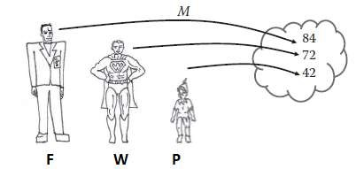

Question 1:

In the above figure if we say that “F is taller than W”, how we can write that in numerical relation? F>W

Question 2:

Write “F is taller than W” as mapping? M(F)>M(W)

Question 3:

How “taller than” can be written in numerical relation? >

Question 4:

What attribute we are measuring? Height

Question 5:

What are the entities described in the above figure? F, W, P

Question 6:

6.1- Write one unary empirical relation relative to above figure?

F is tall

6.2- Why it is unary?

F it’s not being compared to any other entity.

Question 7:

7.1- Write one binary empirical relation relative to above figure?

P isn’t taller than W

7.2- Why it is binary?

2 entities are being compared.

Question 8:

8.1- Write one possible ternary empirical relation in this figure?

F is taller than W and P.

8.2- Why it is a ternary relation?

Because 3 entities are being compared.

Question 9:

Statement: “If the person in the above figure have height greater than 80, they would be considered tall.”

9.1- Based on the above statement, if the height of F is greater than 80 then how we can write it in the form of unary numerical relation?

F>80 or F is tall.

9.2- and what would be the representation condition?

F is tall IFF F>80.

Question 10:

Statement: “If the height of anyone in the above figure is more than 20cm than the others the first person would be considered much taller than.”

If we say that the height of W is 20cm more than the height of P.

Then what would be the representation condition for that?

W is much taller than P.

IFF M(W) > M(P) + 20